Which of the following is wrong for the valency of carbon?
A. $=C=$
B. $-C≡$
C. $=C≡$
D. None of these
ANSWER: C

The ‘ene’ suffix is used for ______.
A. $C-C$
B. $C=C$
C. $C≡C$
D. None of these
ANSWER: B

1-butene-3-yne is the IUPAC name of ____.
A. Divinyl acetylene
B. Vinyl acetylene
C. Diethyl acetylene
D. Dimethyl acetylene
ANSWER: B

Which of the following gas is known as Marsh gas?
A. $CH_{4}$
B. $C_{2}H_{6}$
C. $C_{3}H_{8}$
D. $C_{4}H_{10}$
ANSWER: A
Which of the following is the simplest member of alkyne?
A. $CH_{4}$
B. $C_{2}H_{4}$
C. $C_{2}H_{2}$
D. $C_{2}H_{5}$
ANSWER: C
The IUPAC name of $H_{2}C=CH-C≡CH$ is
A. 1-butene-3-yne
B. 3-butene-1-yne
C. but-3-ene-1-yne
D. None of the above
ANSWER: A
Which of the following is suitable structure for 4-methyl-1-pentyne?
A. $H_{3}C-C≡C-CH_{2}-CH_{3}$
B. $H_{3}C-HC\left(CH_{3}\right)-CH_{2}-C≡CH$
C. $HC≡C-CH_{2}-CH_{2}-CH_{3}$
D. $HC≡C-CH(CH_{3)}-CH\left(CH_{3}\right)-CH_{3}$
ANSWER: B

Which of the following statement is incorrect from the following?
A. If double bond and triple bond are present at the same position, then preference will be given to triple bonds.
B. If double bond and triple bond are present at the same position, then preference will be given to double bonds.
C. If alkyl substituent and double bond are present at the same position, then double bond will be preferred.
D. If methyl and ethyl alkyl substituent are present, then preference will be given to methyl
ANSWER: A

Which of the following is the simplest alkene?
A. $CH_{3}$
B. $C_{2}H_{4}$
C. $C_{3}H_{6}$
D. $C_{4}H_{8}$
ANSWER: B
Which of the following IUPAC name is correct for this compound $CH_{3}-CH\left(CH_{3}\right)-CH_{2}=CH_{2}$?
A. 2-Vinyl propane
B. 3-methyl-1-butene
C. 1,1-dimethyl-2-propene
D. 1-isopropyl ethylene
ANSWER: B
The IUPAC name of ${CH}_{3}-CH=C\left(CH_{3}\right)-CH_{3}$ is
A. 2-methyl-2-butene
B. 3-methyl-2-butene
C. 2-methyl-2-butane
D. 3-methyl-2-butane
ANSWER: A

Which of the following compound is 3,4-dimethyl-1-pentene?
A. $HC≡C-CH\left(CH_{3}\right)-CH=CH_{2}$
B. $CH_{3}-CH_{2}-CH=CH-CH_{3}$
C. $CH_{3}-CH\left(CH_{3}\right)-CH\left(CH_{3}\right)-CH=CH_{2}$
D. $CH_{3}-CH\left(CH_{3}\right)-CH_{2}=CH_{2}$
ANSWER: C
The IUPAC name of $H_{2}C=C=CH_{2}$ is
A. Propene
B. Pentdiene
C. Pentane
D. Propdiene
ANSWER: B
The correct IUPAC name is:
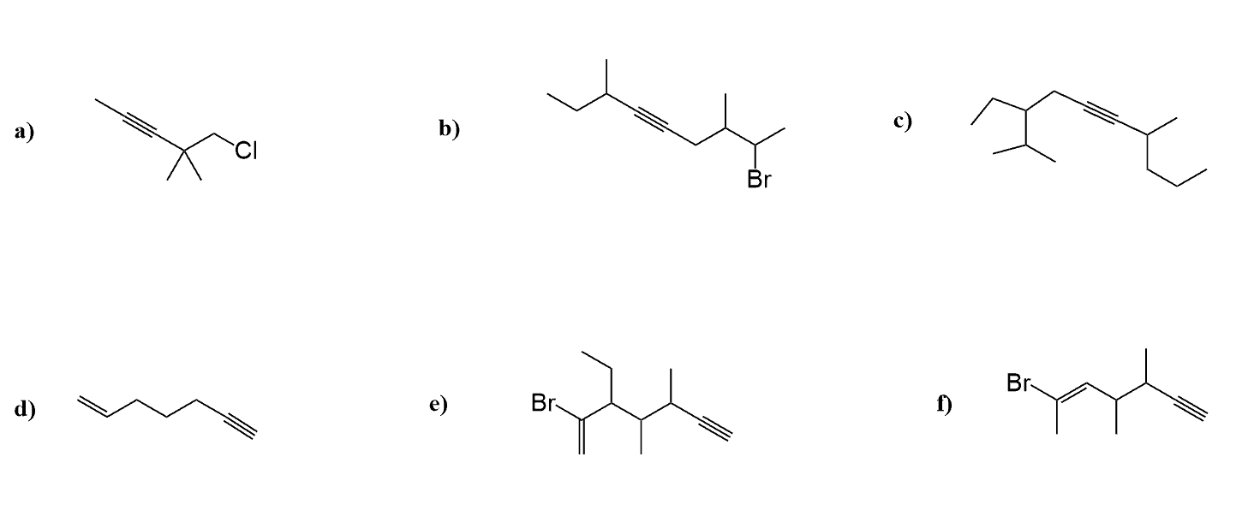
A. 4,4-dimethyl-5-chloropent-2-yne
B. 2,2-dimethyl-1-chloropent-3-yne
C. 2,2-dimethyl-1-chloropent-2-yne
D. 4,4-dimethyl-5-chloropent-3-yne
ANSWER: A
The correct IUPAC name is:

A. 1-heptene- 6-yne
B. 1-heptyne- 6-ene
C. 1-hexyne- 6-ene
D. 1-heptyne- 6-ene
ANSWER: A

